Christmas Day 2012

This is the sky as seen from Madrid (latitude 40N) at 07:30 local time on December 25th 2012.

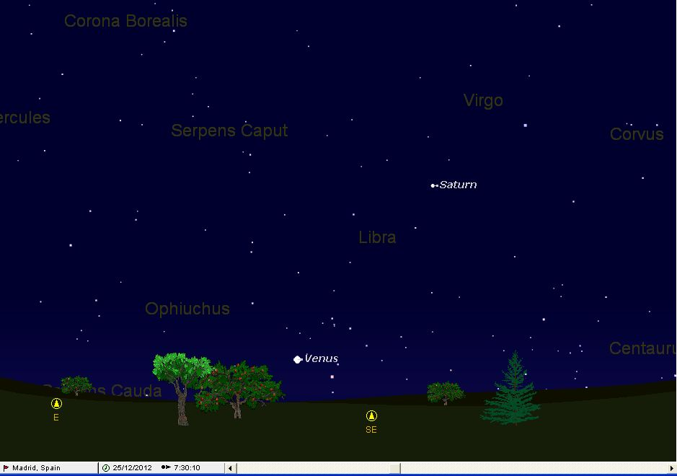

In 2012 the dawn sky on Christmas Day is similar to in 2010. However, both Venus and Saturn are much lower in the sky. Venus is 6 degrees high in Ophiuchus and, despite being magnitude –3.9, is none too easy to see without a very good eastern horizon.

Saturn, the ringed planet is 31 degrees high in Libra. Its rings are opening wider and so it is getting brighter: at Christmas 2012 it is now magnitude 0.6 and clearly slightly brighter than Spica.

